**Current Progress**

The project is in progress now, more functions will be added and the UI will be improved

Login page:

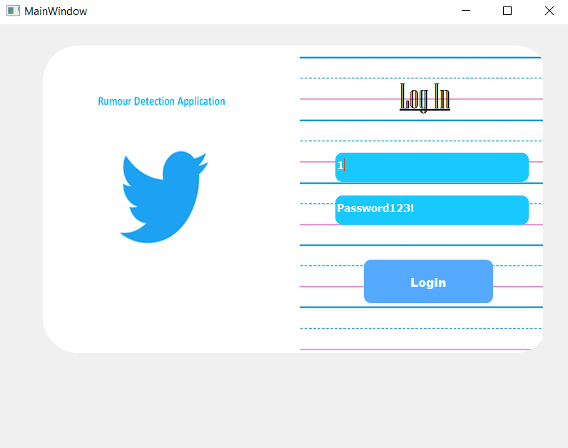

Home Page:

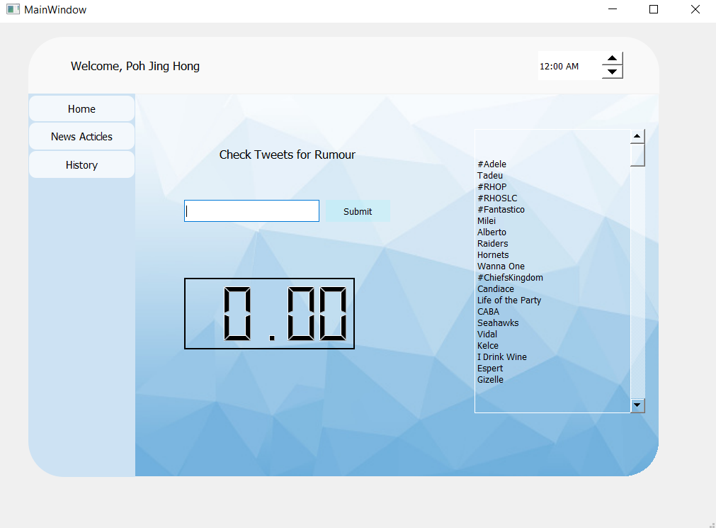

Enter a tweets URL:

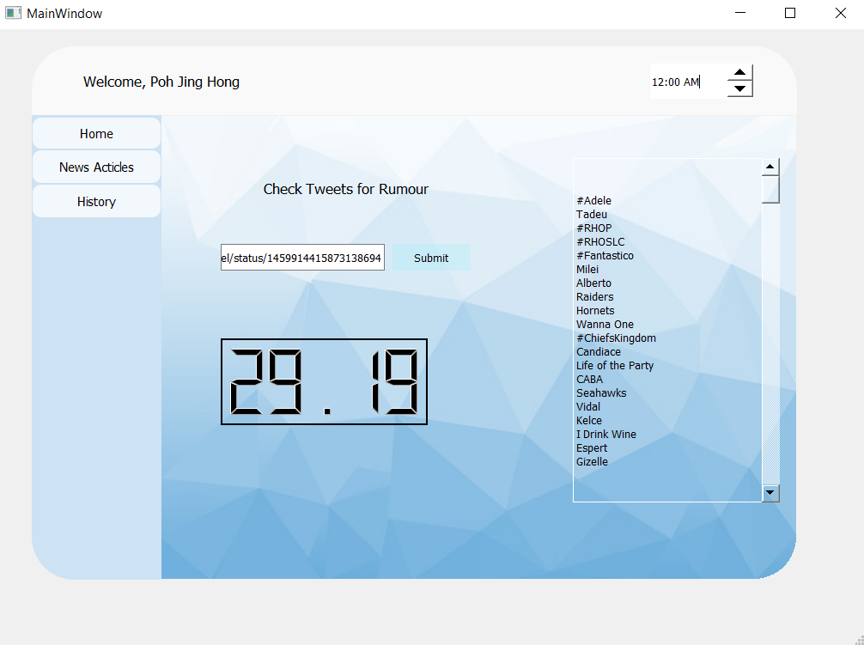

News Articles Page:

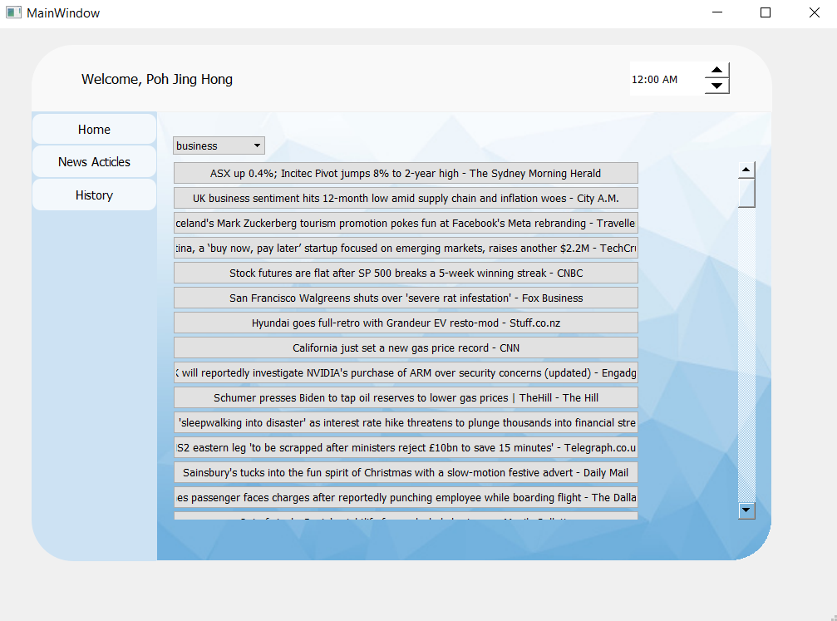

Note: There should have true and false buttons beside each news, the user can determine the news is true or not and report the admin, if the admin accepted the report of user, the news with label of true/false will be added to the training data of the model.

Change Categories:

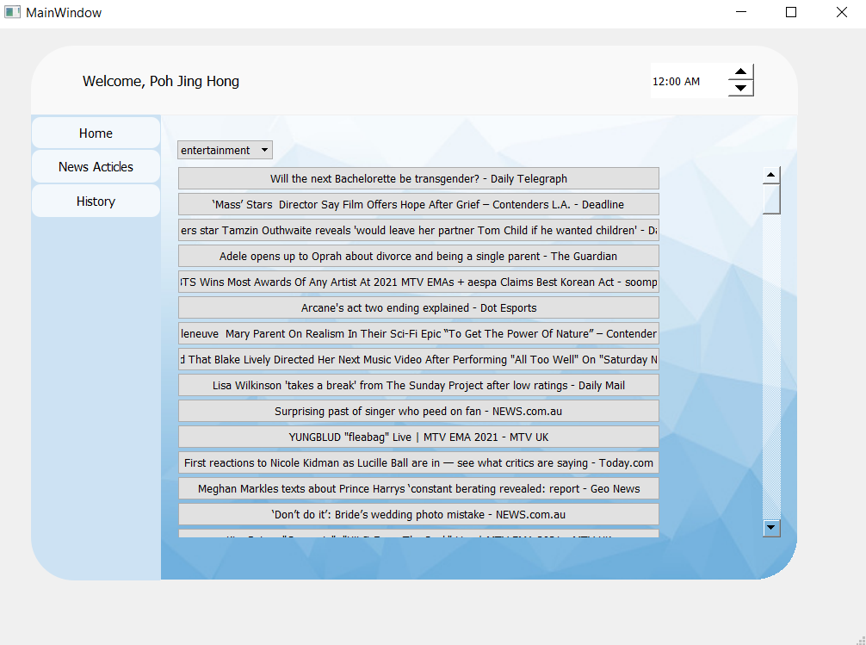

History Page:

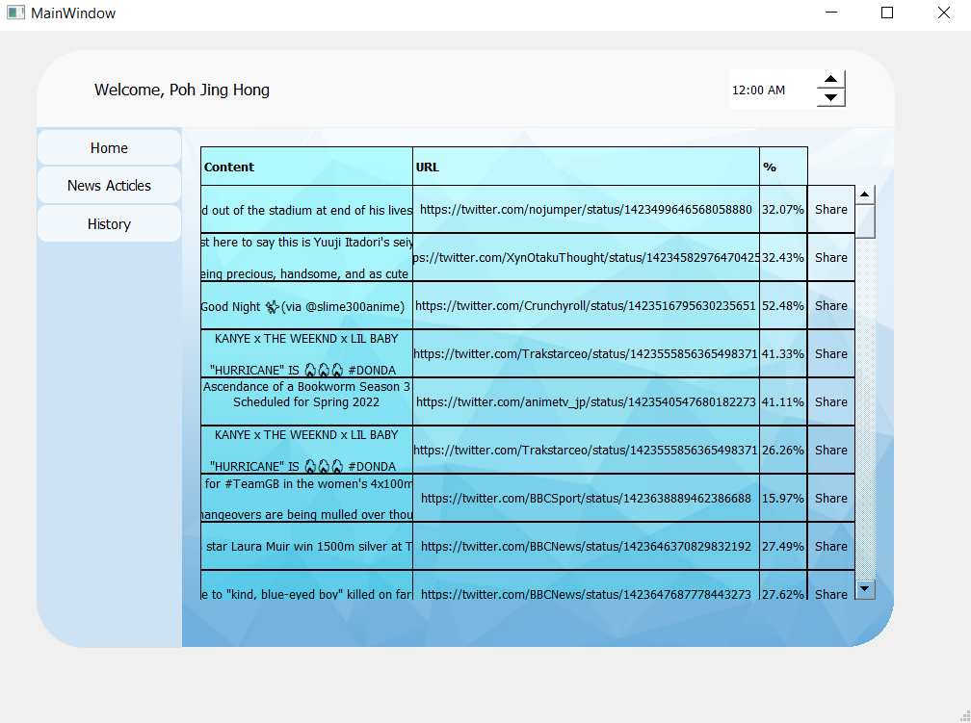

The tweets that user check for rumour before will be recorded at this page, the user can clicks the URL and go to the tweets or clicks the share button to share the tweets and its rumour percentage.

Click on URL

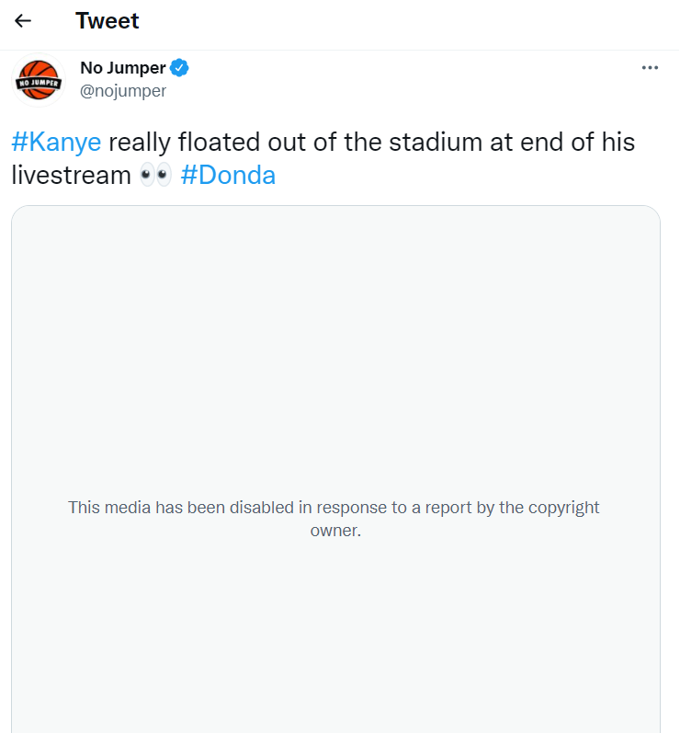

Share the tweets

